AFKA-CH 8 June 2021

SUBJECT: First Army Standard Ceremony Operating Procedure

- PURPOSE: This SOP establishes the standing operating procedures regarding all First Army memorial ceremonies.

- APPLICABILITY: This SOP applies to all units assigned or attached to First Army.

- SCOPE: This SOP covers the following areas:

General 2
Policies 2
Explanation of Terms 2
Procedures 2
Responsibilities 3
Appendices A-L 5-20
- REFERENCES:

a. FM 1-05, Religious Support

b. AR 165-1, Chaplain Activities in the United States Army

c. AR 600-8-1 Army Casualty Program

d. ATP 1-05.02 Religious Support to Funerals and Memorial Ceremonies and Services

5. GENERAL. All First Army religious support to funerals, memorial ceremonies, and services will comply with current DA, FORSCOM, and Chief of Chaplains policies and guidance. This SOP provides direction to First Army UMT’s and Chaplain Sections and guidance to all First Army commands. Direct requests for exception to this SOP through the First Army chain of command to the First Army Chaplain Section.

6. POLICIES. Memorial events are intended to honor the loss of life of a Soldier or Civilian while also providing an outlet for grief. The outlined procedures guide commanders, UMT’s, and Chaplain Sections in conducting memorial ceremonies. These procedures apply to conducting of services at a chapel or another designated facility. During field exercises or deployments, METT-T determines the location and time lines for the memorial ceremony or other memorial honors. This SOP is specifically for a memorial ceremony, which is a command led, official, government ceremony of a patriotic and inspirational nature, not faith specific or sectarian in nature. Chaplain Sections may still assist and participate in memorial ceremonies.

7. EXPLANATION OF TERMS.

a. A funeral or memorial service is a religious event. When possible, a military chaplain of like belief will conduct the funeral or memorial service consistent with the faith group of the deceased. The chaplain’s denomination consistent with the deceased’s beliefs guide the conduct of the service. Commanders may encourage Soldiers and DA Civilians to attend but the service is not mandatory. Attendance is voluntary.

b. A memorial ceremony is a command ceremony, not a religious service. The commander typically leads the ceremony and the chaplain participates and advises on the event. The Chaplain is the subject matter expert. Attendance can be mandated.

8. PROCEDURES.

a. Conduct memorial events at the unit level of the deceased member. Due to the First Army command structure, conduct funeral and memorial services at the brigade level and other echelons by exception.

b. Conduct memorial events at the earliest date at the discretion of the Commander in order to allow maximum unit member and family participation. VIP attendance is a lower priority for setting the date and time of the event.

c. The hosting unit will produce the memorial event bulletin. Bulletins will not include symbols of civilian organizations or affiliations. The bulletin will include the following (see Appendix D):

- Front cover: picture of the deceased Soldier/DA Civilian or an American Flag.

(2) Inside cover, left panel: unit identifying information location and order of service.

(3) Inside cover, right panel: deceased name and rank, unit crest, First Army insignia, and
military obituary.

(4) Back cover: appropriate Scripture/reading (approved by the Family), and a religious symbol indicative of the deceased soldier’s faith (approved by the Family), and the Department of the Army emblem.

d. Memorial displays will conform to the standard established in ATP 1.05.02. The unit CSM will supervise the drill and ceremony. Unit Religious Affairs NCOs will advise and assist the CSM. See Appendix G.

e. Memorial events may include special music provided by contract or volunteer musicians. The Chaplain will approve selection of music in consultation with the Family.

f. The last roll call may be used during the memorial event. It is an emotional event and commanders must advise the Family of the additional emotional grief they may experience as a result of the last roll call. The Family may request not to have the last roll call. The Commander selects unit members to participate in the last roll call and will rehearse prior to the ceremony.

g. Commanders will designate the uniform for the event participants and attendees. Participants will typically wear Army Service Uniform (ASU) while attendees may wear the uniform for the day. Final discretion is up to the Commander.

h. Expect memorial events to last approximately 30 minutes. It must not give the appearance of being “rushed” but proceed smoothly with no noticeable delays.

i. In the event of multiple deaths units may choose to conduct a single unified event that includes members from multiple units.

j. Memorial events typically include a Commander’s remarks, remarks from no more than three unit representatives, and a reflection by the Chaplain. Choose speakers wisely, ensure they write their remarks completely, the Chaplain reviews, and all personnel rehearse the full written text during all rehearsals. Remarks will last no longer than five minutes each. Funerals and services may include other unit members for prayers or readings.

k. A memorial event is for unit members. Family members are welcome to attend and may be consulted when scheduling the event. Their presence is voluntary. If Family members attend the event, the unit will designate an appropriate escort. Commands will coordinate Family attendance and event inputs through the Casualty Assistance Office, as necessary.

l. Reserve VIP seating according to Army protocol. Families electing to attend events will have reserved seating, typically in the front right of the event setting.

m. Sequence of events if the Family is present:

(1) The escort will assemble the Family in an appropriate area of privacy, if available. Five minutes prior to the beginning of the service, the escort will lead the Family to their seats. The Commander, CSM, and other designated leaders will follow the Family and sit in their designated seats.

(2) Upon completion of the event, the command representatives will depart first. After the command has departed, the other attendees will be invited to pay their last respects to the deceased and the Family (if present). Lastly, the escort will lead the Family to an appropriate area of privacy following the same route by which they entered.

9. RESPONSIBILITIES.

a. Unit Commanders maintain responsibility for memorial events. They approve the event order, event details, and event participants.

b. The CSM and unit NCOs have responsibility for the drill and ceremony, site set-up, and clean-up.

c. Unit Ministry Teams and Chaplain Sections will advise the command on event processes, provide event preparations, and provide religious support to unit and Family members. They will submit an AAR to their command and senior Chaplain Section NLT 5 days following the event.

d. The point of contact is the First Army Command Chaplain Section at: 309-782-9688 or
usarmy.ria.first-army-hq.mbx.chaplain@mail.mil.

Robert S. Brown
CH (COL), USA
Enclosures Command Chaplain

TABLE OF CONTENTS (APPENDIXES):

A. Memorial Event Checklist 5-6
B. Officiating Chaplain’s Memorial Event Checklist 7
C. Checklist of Eulogy/Memorial Tribute Data 8
D. Memorial Event Bulletin 9-12
E. Format for the Last Roll Call 13
F. Announcement to Command Group 14
G. Arrangement of Colors, Boots, Advanced Combat Helmet, etc 16
H. 17
I. Example Letters of Sympathy and Condolence 18-19
J. Example Elements of the Eulogy and Tribute 20-21
K. After Actions Review/Report Format

APPENDIX A

COMMAND GROUP’S MEMORIAL CEREMONY/SERVICE CHECKLIST

Yes No Date
HAS THE COMMANDER OR OIC:

1. Coordinated with the command group prior to ____ ____ ____
determining time and date of the ceremony (See Appendix F)?

2. Coordinated bulletin support and certified the accuracy ____ ____ ____
of the information that will appear in the memorial ceremony
bulletin (See Appendix C)?

3. Coordinated the arrival of the proper equipment (Rifle ____ ____ ____
with bayonet, empty magazine, Advanced Combat Helmet,
Identification tags, and boots) at the chapel for the rehearsal
at least two hours before the ceremony?

- Coordinated the movement of the unit colors to the ____ ____ ____
designated area of ceremony?

5. Coordinated with the Color Guard/Rifle Team for the 21 ____ ____ ____
volley salute?

6. Designated at least two ushers for the Ceremony and arranged ____ ____ ____
for their arrival at the chapel one hour prior to the Ceremony?

7. Designated an escort for the family (if applicable)? ____ ____ ____

8. Coordinated the seating arrangement of troops, family ____ ____ ____
members (if applicable), and special guests?

9. Designated the senior leader responsible for conducting ____ ____ ____
the last roll call (if applicable)?

10. Coordinated with an Army Band for providing a ____ ____ ____
Taps and bugler to arrive at the chapel thirty minutes prior
to the Ceremony (Taps may be prerecorded, or via civilian
bugler)?

11. Planned for retrieving all items used in the Memorial ____ ____ ____
display to include the rounds fired which are given to the
family?

12. Planned to coordinate for video taping the Ceremony to
send to family members? ____ ____ ____

13. Coordinated with the S1 for posthumous award? ____ ____ ____

APPENDIX B

OFFICIATING CHAPLAIN’S CHECKLIST

Yes No Date
HAS THE OFFICIATING CHAPLAIN:

- Coordinated with the Commander and staff concerning ____ ____ ____
responsibilities, Ceremony participants, details?

- Coordinated the use of the site for the rehearsal and the ____ ____ ____
actual Ceremony?

- Coordinated, special music, and the services of the musician? ____ ____ ____

- Coordinated bulletin preparation and approval? ____ ____ ____

- Prepared appropriate remarks? ____ ____ ____

- Assisted the Commander in preparing his/her remarks? ____ ____ ____

- Offered to assist and review peer remarks? ____ ____ ____

- Contacted family and coordinated with the Casualty Affairs ____ ____ ____
Officer.

- Coordinated and updated tasks with the RA? ____ ____ ____

- Coordinated with the Ceremony OIC and CSM concerning ____ ____ ____
rehearsal times and Ceremony events?

- Attended the rehearsal and coordinated with all participants? ____ ____ ____

- Contacted senior UMT regarding Ceremony details? ____ ____ ____

APPENDIX C

CHECKLIST OF EULOGY/MEMORIAL TRIBUTE DATA

A. Civilian History

1. Date and place of birth _____________________________________________________

2. Home of record (present residence)____________________________________________

3. Civilian schools attended (list degrees, certificates)
__________________________________________________________________________

4. Married: Yes ___ No ___ Date ______ Place __________________________________

5. Family (names and relationships) _____________________________________________ ___________________________________________________________________________ ___________________________________________________________________________
6. List significant positions in civilian life ________________________________________ ___________________________________________________________________________
7. Church and/or civilian organizations ___________________________________________________________________________

B. Military History

1. Date and place of entry active duty ____________________________________________

2. Sequence of assignments with dates and positions held
___________________________________________________________________________ ___________________________________________________________________________ ___________________________________________________________________________

3. Military schooling _________________________________________________________ ___________________________________________________________________________

4. Awards and decorations ____________________________________________________ ___________________________________________________________________________ ___________________________________________________________________________

5. Length of service ______________________ Retirement date ______________________

C. Other Information

1. Date and place of death _____________________________________________________

2. Survivors and relationship___________________________________________________

APPENDIX D-1
(Bulletin Front)

A COMPANY
1ST BATTALION
6TH INFANTRY REGIMENT

1ST ARMY
DIVISION EAST/WEST



(The American Flag may be replaced with a picture of the deceased if appropriate picture is available).

In Memory of
Private First Class
John A. Doe, Jr.
Date of Birth – Date of Death

APPENDIX D-2
(Inside Cover, Left Panel)

Unit
Location of Ceremony

_____________________________________________________________________________
Time Date

PRELUDE

*NATIONAL ANTHEM (Played or Sung)

*INVOCATION Chaplain’s Name

COMMANDER’S REMARKS Commander’s Name

SOLDIER REMARKS Solider #1 Name
Soldier #2 Name

[OPTIONAL READING(S)] [Reader Name, if any]

[OPTIONAL SPECIAL MUSIC] [Musician Name, if any]

MEMORIAL REMARKS Chaplain’s Name

*BENEDICTION Chaplain’s Name

*LAST ROLL CALL (See Appendix E)

*FIRING OF THE VOLLEYS Color Guard

*SOUNDING OF TAPS Bugler

*POSTLUDE AND RETREAT OF OFFICIAL PARTY AND FAMILY

* Please Stand

APPENDIX D-3
(Inside Cover, Right Panel)

******************************************************************************

IN MEMORIAM
JOHN A. DOE, JR.
PRIVATE FIRST CLASS

BORN: 1 September 1989 DIED: 5 November 2020
******************************************************************************

Private First Class John A. Doe, Jr.

Private First Class John A. Doe, Jr. was born in Arlington, Texas on 1 September 1989. His military career began in October 2009 with his enlistment into the US Army. After completing Basic Training and AIT, he successfully completed Air Assault. He spent 6 years with the prestigious 75th Ranger Regiment in which he was assigned as a rifleman, machine gunner, and team leader. While assigned he was successful in graduating from US Army Ranger School.

PFC Doe received an honorable discharge from active duty in 2015. He joined the Army Reserves in 2015. During his time in the Reserves he met his wife Wanda. He reenlisted into the Texas Army National Guard in August of 2017 as a 19D, Cavalry Scout.

PFC Doe rejoined Active Duty in September of 2018 and was assigned to 1st Platoon, Alpha Company, 1-6 IN. During this time he served as a Squad Leader. PFC Doe’s awards include the Meritorious Service Medal (posthumously), Army Commendation Medal, and Army Achievement Medal.

He is survived by his wife Wanda, daughter Jane, son John, Jr., father Donald Doe, and mother Donna Doe.

A COMPANY

1/6th Infantry

APPENDIX D-4
(Back Cover)

John 14:1-4

“Do not let your hearts be troubled. You believe in God;
believe also in me. My Father’s house has many rooms;
if that were not so, would I have told you that I am going
there to prepare a place for you? And if I go and prepare a
place for you, I will come back and take you to be with
me that you also may be where I am.
You know the way to the place where I am going.”




APPENDIX E Script

APPENDIX D
MEMORIAL CEREMONY SCRIPT
PRE-CEREMONY
-60 Memorial Stand / Colors Display Ready
-60 Script Binder Placed / Ready
-60 Final Sound and Video Check / Ready
-60 All Reservation Signs Placed for: Official Party, GOs / Senior CMD Teams
-45 Ushers In Place / Ready (Doors to sanctuary / auditorium / seating to hand out programs; Ushers for Senior CMD Teams / DVs, if applicable)
-30 Prelude Music / Firing Team / Bugler In Place / Ready
-30 Ushering as elements arrive
-30 Escorts Ready For GO / DVs at Flight line
-20 Prelude Music Begins . . . Unit Soldiers, w/ Roll Call Soldiers ready, seated
-5 Narrator announces to silence all cell phones and electronic devices
-2 Command Group Seated, front left, facing platform
-1 Official Party enters, far front left, facing platform

MEMORIAL CEREMONY

NARRATOR:

(-5) LADIES AND GENTLEMEN, PLEASE TAKE YOUR SEATS, THE
MEMORIAL CEREMONY WILL BEGIN IN FIVE MINUTES. OUT OF RESPECT,
PLEASE TURN OFF ALL CELL PHONES OR PLACE THEM IN SILENT MODE. WE ALSO ASK THAT YOU REFRAIN FROM TAKING FLASH PHOTOGRAPHY DURING THE CEREMONY.

(-2) GO / SR CMD TEAMS / DVs USHERED TO SEATS (Front Left)

(-1) OFFICIAL PARTY ENTERS / SEATED (Far Front Left)

(Command Group / Official Party to be present and ALL seated, make eye contact / get head nod from Chaplain or OIC to begin ceremony) Note: ceremony only begins on below queue.

NARRATOR: GOOD MORNING / AFTERNOON / EVENING, ON BEHALF OF RANK / NAME OF COMMANDER, COMMANDER, NAME OF BN / TASK FORCE, AND COMMAND SERGEANT MAJOR XXXXX, THANK YOU FOR ATTENDING TODAY’S MEMORIAL CEREMONY IN HONOR OF XXXXX.
LADIES AND GENTLEMEN, PLEASE RISE FOR THE NATIONAL ANTHEM AND REMAIN STANDING FOR THE INVOCATION DELIVERED BY CHAPLAIN XXXXX, THE NAME OF UNIT, BATTALION / BRIGADE CHAPLAIN.
(National Anthem is played)

(Chaplain gives the invocation)

CHAPLAIN: INVOCATION . . . PLEASE BE SEATED.
(Should Chaplain forget to seat guests, Narrator will execute prior to remarks below)
NARRATOR: LADIES AND GENTLEMEN, THE COMMANDER OF NAME OF UNIT, RANK / NAME OF COMMANDER.

(Commander’s Remarks complete)
NARRATOR: LADIES AND GENTLEMEN, WE WILL NOW HEAR FROM RANK / NAME OF FRIEND, A FRIEND OF RANK / NAME OF DECEASED.
(Remarks complete)

NARRATOR: LADIES AND GENTLEMEN, CHAPLAIN NAME OF CHAPLAIN, THE BATTALION / USARCENT CHAPLAIN, NAME OF UNIT / TASK FORCE WILL NOW OFFER THE MEMORIAL REFLECTION.

CHAPLAIN: LADIES AND GENTLEMEN, PLEASE STAND FOR OUR BENEDICTION, AND REMAIN STANDING, FOR THE FINAL ROLL CALL, THE FIRING OF VOLLEYS, THE SOUNDING OF TAPS, AND PAYING OF PERSONAL HONORS BYTHE OFFICIAL PARTY AND COMMAND GROUP. . .

CHAPLAIN: I invite you to pray . . .
(Benediction complete)

1SG / NCOIC OF FINAL ROLL CALL:
(The designated leader, typically the 1SG, will post / stand at the front of the seating during the benediction, then facing Soldiers of his / her unit, and in command voice, commence with the Final Roll Call:
*Call the Company / Unit to Attention!
“Private ”…………………………(SM replies, “Here, First Sergeant.”)
“Specialist ”…………………………(SM replies, “Here, First Sergeant.”)
“Sergeant (LT / CPT, if deceased is officer) Lee”…………..(SM replies, “Here,
First Sergeant.”)
“CPT Page”………………….(There is silence.)
Pause three seconds in silence, then the name is called again slowly and deliberately with the addition of the first name:
“CPT James Page”………………….(Again, there is silence.)
After three more seconds of silence, the full name is called as follows:
“CPT James A. Page” …………...... (Again, silence.)

FIRING PARTY: (3 Volleys Fired)

BUGLER: (TAPS is played, immediately following; NO salute if indoors)

POSTLUDE:
(“Amazing Grace” Long Play “Phase I” Postlude music begins immediately (recorded or live Bag Pipes), all will remain standing)
(Ushering / Rendering of Personal Honors by Official Party, then GO / Senior Command Team / DVs (in that order!) is initiated IMMEDIATELY upon playing of Postlude Music.) (Media Tribute, if utilized (optional), may begin at this point) ----------------------

SEQUENCE OF RENDERING OF PERSONAL HONORS:

USHERS: (2)
(Facing platform, all typically move from left to right, AS USHERED / INDICATED, moving to Memorial Display, rendering honors, departing to the right and out of the area . . . the Official Party will then setup a receiving line for the GOs / Senior Command Teams / DVs, and others, as they desire, to the back of the gathering, out of line of sight and hearing of those waiting to render Personal Honors.)
- OFFICIAL PARTY:
(Those participating in the Ceremony, and CO / BN Command Teams)
- GOs / SENIOR COMMAND TEAM / DIGNITARIES
(Typically DIV GO Representative(s) / Fellow CMD Team / Dignitaries on Front Left Row)
(Once last CMD Team or Dignitary has saluted and moved away from Memorial Stand,

AMAZING GRACE FADES OUT so that following announcement can be made:

***NARRATOR - LADIES AND GENTLEMEN, THIS CONCLUDES OUR MEMORIAL CEREMONY. THANK YOU FOR ATTENDING TODAY. SHOULD YOU DESIRE TO RENDER PERSONAL HONORS, YOU MAY DO SO AT THIS TIME, AS THE
USHERS DIRECT YOU. SHOULD YOU BE UNABLE TO REMAIN, YOU MAY DEPART NOW QUIETLY. AGAIN, THANK YOU FOR HONORING NAME OF DECEASED WITH YOUR PRESENCE HERE TODAY.

(“Phase II Postlude Music / Media Tribute now begins for remainder of paying of Personal Honors by whomever remains, in the following order.)

USHERS:
- DVs: OTHER USARCENT / BN COMMAND GROUPS / USARCENT SENIOR STAFF
- OTHERS PRESENT (CSM is encouraged to consider moving groups through from left to right in larger numbers (6-10 at a time)
- IMPACTED UNIT, COMPANY, PLATOON, SQUAD
(Those closest to Soldier are typically staged to go last, to allow maximum time in expressing their personal respects, honors and emotions.

APPENDIX F

FORMAT FOR THE LAST ROLL CALL

- The Last Roll Call will be used in a Memorial Ceremony after the command has advised the family about the impacts. Commanders must approve its omission.

- The deceased Soldier’s Commander will designate a senior leader, normally the First
Sergeant, to conduct the Last Roll Call.

- The Commander will designate the three Soldiers who will participate in the Last Roll Call.

- The three Soldiers will sit with their unit in the chapel. They need not be seated together.

- The designated leader will sit towards the front of the chapel.

- Upon completion of the Benediction, the designated leader will position himself/herself next to the display stand and proceed with the Last Roll Call (this sample assumes the First Sergeant is performing the Last Roll Call):

“Sergeant Smith”………………………….(Smith replies, “Here, First Sergeant.”)

“Specialist Jones”…………………………(Jones replies, “Here, First Sergeant.”)

“Private Lee”………………………………(Lee replies, “Here, First Sergeant.”)

“Private Doe”……………………………...(There is silence.)

After five seconds of silence, the name is called again:

“Private First Class John Doe”…..…………(Again, there is silence.)

After five seconds of silence, the full name is called as follows:

“Private First Class John A. Doe, Jr.”……. (Again, silence.)

7. Firing of the Volleys.

- Immediately after the firing of the volleys the bugler plays Taps. Participants may salute indoors depending upon the drill and ceremony decision by the CSM.

APPENDIX G

Potential N – HOUR SEQUENCE
(Time dependent on unit mission and family availability)

N+1----Unit notified of casualty

N+2----Unit leaders shall have a meeting prior to NOK notification

N+3----Contact CAO to receive assistance with verification and further instructions

N+4----CAO senior to the casualty will be appointed from the unit

N+5----CAO with assistance from the Chaplain will contact the PNOK and will be the primary point of contact for the family

N+6----Unit Chaplain and Staff members will ensure all pertinent regulations are reviewed to advise Commander on Memorial Ceremony

N+7----Conduct IPR’s to ensure a successful Ceremony

N+8----Review and approve all documents generated for the Ceremony

N+9----Staff members and Chaplain section work together as they carry out various assigned responsibilities

N+10----Ensure that everything needed for the memorial display and setup is identified and accounted for

N+11----Ensure that the unit has a picture of the Soldier, dogtags, helmet, and boots

N+26----Ensure all participants are identified and uniform standards is highlighted

N+27----Unit/Chaplain obtain biographical and family information for the bulletin

N+28----Identify time and location of the Ceremony

N+29----Coordinate attendance of all VIPs and develop seating plan

N+30----Advise, process and assist with posthumous award/promotion requirements

N+31----Request video support from TASC /PAO in order to film the Ceremony

N+32----Ensure request for Bugler is approved and make arrangement for Bugler to arrive at Chapel 30 minutes prior to Ceremony

N+33----Selection of appropriate unit members to participate in the Ceremony

N+34----Ensure all remarks are drafted, typed, checked for accuracy, and sent to the Chaplain for posting in the Memorial Bulletin

N+35----Schedule the Ceremony to be held at the local Chapel

N+50----Provide boots, weapon, ACH, etc. for display

N+51----Ensure appropriate flags are present

N+52----Designate an escort for the family

N+53----Implement a VIP and guest parking plan at the Chapel

N+54----Coordinate to have a PA system capable of playing the back-up “Taps” tape or CD for the rehearsals and Ceremony

N+55----Coordinate the services of an organist/pianist

N+56----Complete memorial bulletin, approved by Chaplain

N+57----Ascertain if family and/or friends will be attending the Ceremony

N+58----Have the Chapel neutralized

N+59----Coordinate times of rehearsal. Conduct a walk-through the day before the Ceremony and then a dress rehearsal prior to the Ceremony

N+73----Instruct ushers on seating those attending

N+74----Prepare a Memorial Book for the family

N+75----Execute Memorial Ceremony

APPENDIX H

DISPLAY OF COLORS, BOOTS, ADVANCED COMBAT HELMET, ID TAGS, AND WEAPON
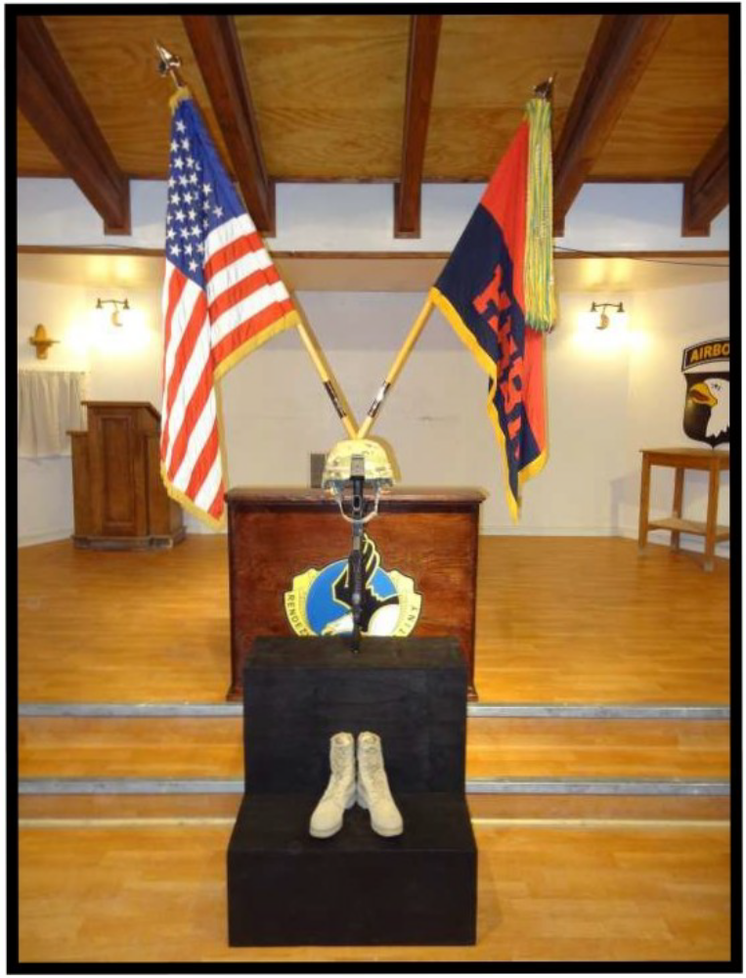

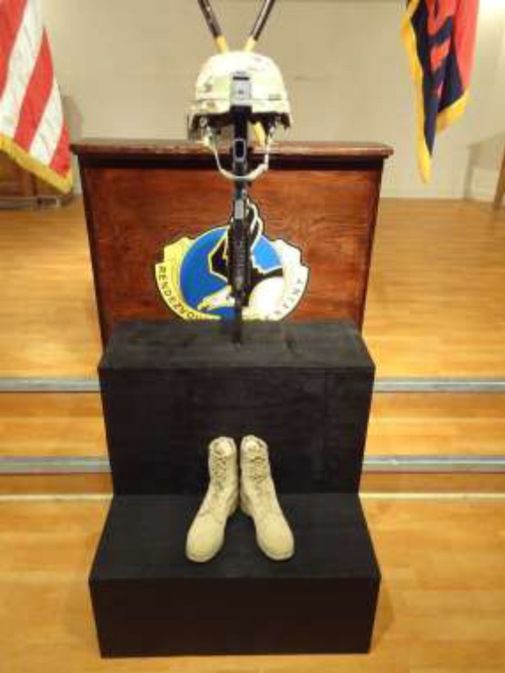
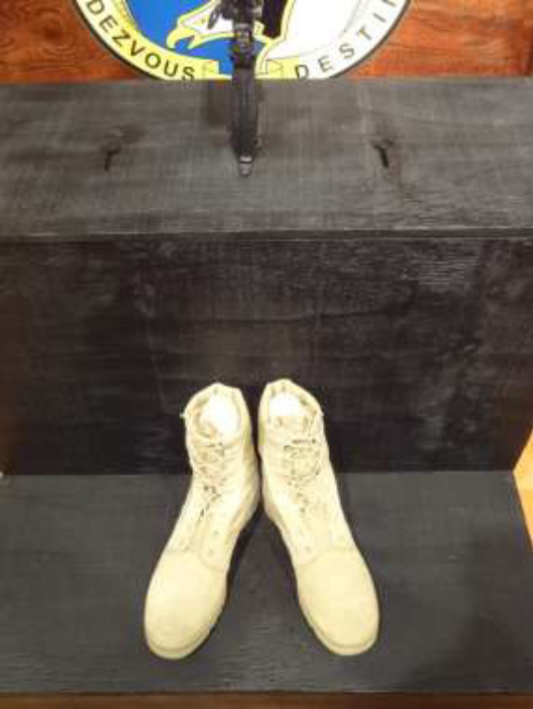

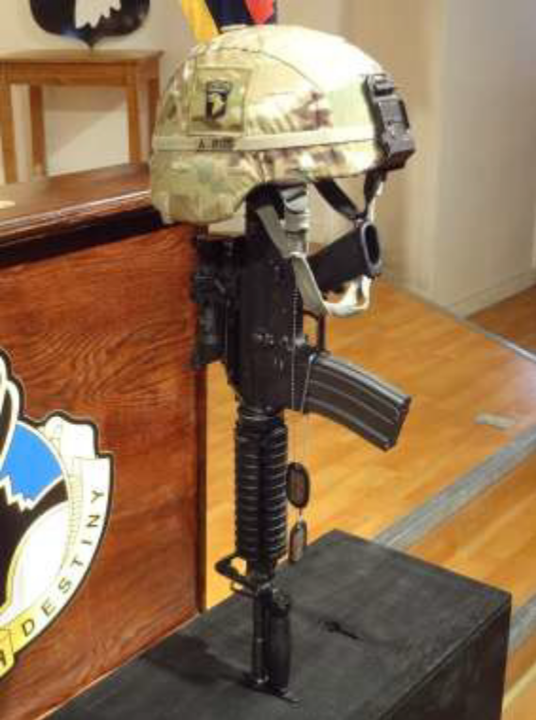
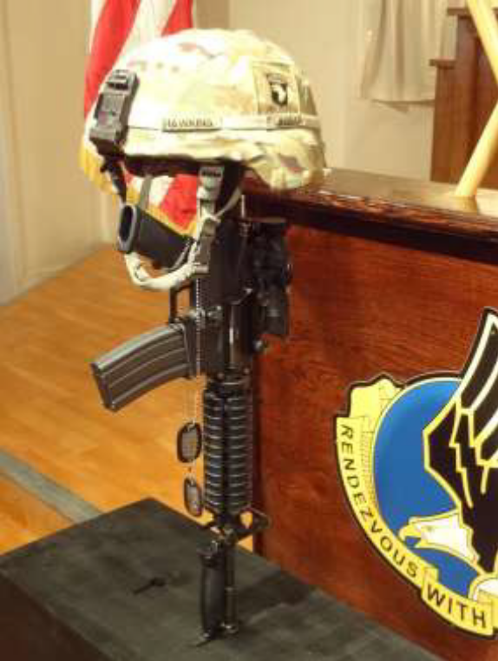
Boots will be clean, stuffed, laces even, ends hidden, and “dressed” (T-Shirts used to smooth / finish the top of inside of boot) to prevent boots from being uneven or flopping over.
For Civilians, no boots or helmet will be used. One picture and one piece of memorabilia connoting their service (badge, logo, etc.).
APPENDIX I

AAR FORMAT

OFFICE SYMBOL Date

MEMORANDUM FOR RECORD

SUBJECT: PFC John A. Doe, Jr. Memorial Ceremony AAR

1. PURPOSE: To identify significant results that could affect future Memorial events in 1A and make recommendations or conclusions on significant findings.

2. FORMAT: Address each strength and deficiency of the Memorial event separately in the
format below and submit AAR to the First Army Command Chaplain’s office NLT five working days following the event.

- Issue

- Discussion

- Recommendation

3. POC is the undersigned at 337-0000.

MIKE D. DOE
CH (Rank) USA
Duty Position

APPENDIX J

Example Letter of Sympathy - Reference AR 600-8-1

Mr. Michael A. Doe Date
123 Maple St.
Anytown, USA 12345

Dear Mr. Doe,

The Soldiers and officers of A Company 1/6th Infantry join me in extending to you our deepest sympathy on the death of your son, Private First Class John A. Doe, Jr.

I know how little the words of an outsider must mean to you at this time – nevertheless, I want you to know how deeply I sympathize with you and your family. In time, it is my hope that you will find personal reassurance in the thought that John died serving his country and that our gratitude as a nation for his service and sacrifice is deep and lasting.

Please know that you and your family are in our prayers at this difficult time.

Sincerely,

JAY W. HOOD
MG, US Army
Commanding

APPENDIX K

Example Letter of Condolence - Reference AR 600-8-1

Mr. Michael Doe Date
123 Maple St.
Anytown, USA 12345

Dear Mr. Doe,

The Soldiers and Officers of A Company 1/6th Infantry join me in extending to you our deepest sympathy on the death of Private First Class John A. Doe, Jr. We know the irreparable loss that you have suffered and fully realize there is little we can say to help you in this moment of sorrow. In time, may you find personal reassurance in the thought that he died in the service of his country and that our gratitude as a nation is deep and lasting.

Our heartfelt condolences are extended to you in your bereavement.

Sincerely,

JAY W. HOOD
MG, US Army
Commanding
APPENDIX L-1

ELEMENTS OF THE EULOGY

1. Identify why “you” are giving the eulogy: Friend, Commander.

2. Summarize the deceased’s personal history and military career, include only positive elements.

3. List the survivors, relationships and include an expression of sympathy.

4. Closing statements: Include the eulogist’s personal feelings and the significance of the loss to the unit and nation.

As his company Commander, I accept the tremendous duty of presenting the eulogy for PFC John A. Doe, Jr. PFC Doe was an outstanding member of this command. He was born on 1 September 1989 in City, State. He lived there throughout his early life and graduated from City High School in 2008.

PFC Doe joined the Army in October 2009. After One Station Training at Ft. Benning, Georgia, he was assigned to A Company, 1st of the 6th Infantry. While there, he participated in numerous/specific deployments/operations. He received the Army Achievement Medal and Army Commendation Medal. During his career he served this unit well. He was an excellent Soldier known for his willing spirit, friendly manner and can-do attitude.

PFC Doe is survived by his loving wife, Joan; his parents, Mr. and Mrs. Doe; and his two brothers, Steve and Mike. To them and his friends, I extend my deepest sympathy and regrets.

PFC Doe died on 5 November 2020 in a one vehicle accident. It is unfortunate that this accident ended his life. His death saddens me and is a great loss to this unit, the United States Army, and the country he so proudly served.

APPENDIX L-2

ELEMENTS OF THE TRIBUTE/EULOGY

We are gathered here this morning in memory of two of our fellow Soldiers, Sergeant_________ and Specialist__________.

Sergeant ___________enlisted on July 8, 2014. After Basic Training and AIT, he came to Europe and spent a tour with the 1st Battalion, 36th Infantry, initially with Company C and later with Headquarters and Headquarters Company. After an assignment with the 2nd Squadron, 1st Armored Cavalry, 2nd Armored Division at Ft Hood, Texas, Sergeant ___________ returned to Europe and Company A on November 6, 2019. Sergeant ________ performed a number of tasks: Recovery Sergeant, Motor Sergeant, and Arms Room NCO. He demonstrated a sense of professionalism and inner pride that were special qualities we all could emulate. He displayed a high level of proficiency and concern that was unparalleled by others. Sergeant _______ was an outstanding example of the professional NCO.

Specialist ________enlisted on July 31, 2015. After Basic Training at Fort Dix and AIT at Fort Benning, he came to Europe and Company A on January 9, 2016, Specialist______ was a Soldier you could always count on to get the job done. He assisted in preparing for the AGI and took responsibility for the records after the inspection. He performed well above that which was expected of his experience. He was respected, well-like, and certainly earned an admirable reputation in the Company.

Around the world, I stand ...ever forward. Over Lebanon’s sands, my rifle steady aimed....and calm returned. At Berlin’s gate, I scorned the Wall of Shame. I am the Infantry!

My bayonet...on the wings of power...keeps the peace worldwide. And despots falsely garbed in freedom’s mantle, falter...hide. My ally in the paddies and forest...I teach, I aid, I lead. FOLLOW ME!

Where brave men fight...there fight I. In freedom’s cause...I live, I Die. From Concord Bridge to Heartbreak Ridge, from the Arctic to the Mekong...the Queen of Battle!

Always ready...then, now and forever, I am the Infantry! FOLLOW ME!

And when our work is done
Our course on earth is run
May it be said, “Well done
Be thou at peace.”

Sergeant ________ and Specialist__________ will be sorely missed by those who knew and admired them as Soldiers and men.

